**Practical No – 8**

**Aim :** Write a Python program to demonstrate the connections to MongoDB

**Q.1) Insert**

from pymongo import MongoClient

client = MongoClient('localhost',27017) #MongoClient('host',port)

db = client.TYCS #client.name_of_the_database

def insert():

try:

empID = input("Enter the ID: ")

empName = input("Enter the Name: ")

empAge = input("Enter the Age: ")

empCountry = input("Enter the Country: ")

db.Employee.insert_one(

{

"_id": empID,

"name": empName,

"age": empAge,

"country": empCountry,

}

)

print("\nData Inserted Successfully.")

except Exception:

print(str(Exception))

finally:

client.close()

insert()

**Output:**

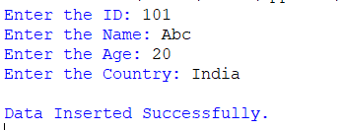



**Q.2)Update:**

#Update in MongoDB

from pymongo import MongoClient

client = MongoClient('localhost',27017)

db = client.TYCS

def update():

try:

name = input('Enter the name of person whose data is to be updated: ')

age = input("Enter the updated age: ")

db.Employee.update_one(

{"name": name},

{"$set": {"age": age}}

)

print("\nData Updated Successfully")

except Exception:

print(str(Exception))

finally:

client.close()

update()

**Output:**

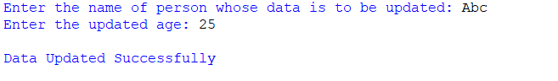

**Q.3) Delete:**

#Delete from MongoDB

from pymongo import MongoClient

client = MongoClient('localhost',27017)

db = client.tycs43

def delete():

try:

id = input('Enter the ID: ')

db.ty248743.delete_one(

{"_id:": id}

)

print('\nData Deleted Successfully')

except Exception:

print(str(Exception))

finally:

client.close()

delete()

**Output**:





**Q.4) Display**

from pymongo import MongoClient

client = MongoClient('localhost',27017)

db = client.TYCS

def display():

try:

id = input("Enter the ID to display record: ")

for i in db.Employee.find({"_id":id}):

print(i)

print("\nRecord displayed")

except Exception:

print(str(Exception))

finally:

client.close()

display()

**Output:**

